Department of Health
Business Continuity Management Framework

Not for external distribution
Plan Title | Business Continuity Management Framework
Version | 0.1
HPRM No
Relevance to | Department of Health
Responsible staff | Risk and Audit unit
Responsible Office | Corporate Services
Date introduced | September 2022
Date of last review
Next scheduled review | September 2024
Related documents
Related Business Continuity Plans
 | Clinical Excellence Division
 | Office of the Director General
 | Office of the Deputy Director General
 | Public and Aboriginal Health Division
 | Strategy and Governance Division
 | Purchasing and System Performance Division
Related Standards and Legislation | AS/NZ ISO 31000 - Risk Management – Principles and guidelines
 | ISO 22301 – Business Continuity Management
 | AS/NZ 5050 - Business continuity – Managing disruption-related risk
Table of Contents
Introduction 4
Objectives 4
Assumptions 4
BCM resource 4
BCM process overview 5
BCP activation and incident management 7
Communication 7
Roles and responsibilities 8
Definitions 9

Introduction
Treasurer’s Instruction 825 Risk Management and Security outlines the requirement for all public sector bodies to manage their material risk. This includes the risk of disruption to the Department’s critical business functions.

The purpose of business continuity management (BCM) is to:
- provide a systemised approach to ensure that critical business functions are maintained or recovered in a timely fashion in the event of a disruption
- minimise the financial, legal, regulatory, reputational, and other material consequences arising from a disruption.

This BCM Framework outlines the Department of Health’s (department) approach to BCM.

Objectives
The objectives of the BCM Framework are to:
- provide an overview of the BCM process
- define incident classification, notification and plan activation parameters
- establish communication protocols
- define BCM roles and responsibilities.

Assumptions
The assumptions made for this framework include:
- In the event of a major or critical disruption and/or disaster, the department may not operate at its normal capability and performance or at a level which is enough to perform and maintain critical business functions.
- Divisions have identified the recovery time objective (RTO) and maximum tolerable period of disruption (MTPD) for specific operational activities as well as the minimum resource requirements (including staff, equipment, systems, and applications) and vital records in their respective business impact analyses (BIA).
- Resources will be prioritised and made available based on the minimum requirements of all divisions in a disruption environment.
- Alternate site(s) have been identified to support the resumption of critical business functions. These sites will be used in conjunction with current workforce arrangements. i.e. working from home.
- The procedures and processes documented in divisional business continuity plans (BCPs) and any other business function workarounds are regularly tested and updated.

BCM resource
Risk and Audit, Corporate Services administer the Business Continuity Sharepoint site that supports implementation of the BCM process and facilitates ease of access and a consistent approach when responding to major or critical incidents. Access is provisioned to members of the Business Continuity Team (BCT), Department Executive Committee (DEC) members and staff nominated by divisional offices. Current versions of the following documents are maintained on the site:
- composition and contact details for members of the BCT (the callout tree)
- action cards for members of the BCT
- business continuity plans and business impact analysis (BIA) workbooks for each division (access restricted at divisional level)
- communication plans
- BIA and BCP templates
- training and testing schedule.

All original documents will be retained in the department’s designated Records Management system.

BCM process overview
The BCM process adopted by the department reflects the principles of international standard on business continuity, ISO22301:2019 Security and resilience – business continuity management systems, as set out below.
Step | Objective | Description | Document Reference
Identify  Risk assessment | To identify, analyse and evaluate the risk and assign a risk rating. | Conducted annually, or as part of the specified risk review period.  Identify any threats that have the potential to harm the department and necessitate the use of a BCP and business function workarounds.  Identify sources of disruption risk that have greatest potential to result in activation of a BCP.  Identify disruption scenarios which will form the basis for developing strategies that support the BCP and business function workarounds. | Risk Management Framework
Analyse  Business impact analysis | To measure the level of impact to organisational activities. | Conducted every 2 years or following organisational change.  Identify recovery priorities.  Identify critical business functions, RTO and MTPD and required resources.  Assess potential business continuity events in relation to financial, staff, reputational, legal, operational, and environmental impacts. | BIA Template
Create  Business continuity plans | To create a BCP for a relevant area of the department, relevant to organisational requirements. | Updated every 2 years, following major changes to organisational functions, or immediately following an incident where the BCP is activated.  Provide a guide to recover critical business functions during a business disruption including prevention, preparation, response, and recovery/restoration.  Use a consistent structure and layout, containing unique division or directorate considerations based on outputs from the BIAs.  Provide a standardised protocol for managing disruption events. | BCP Template
Measure  Test, train, maintain | To test the effectiveness of the overall BCM Framework. | Initial, then every 2 years.  Maintain an overall awareness and understanding of business continuity principles and preparations.  Testing and exercising should include:  - critical business functions, resources, infrastructure.  - recovery strategies.  - communications strategies outlined in the BCP and supporting recovery plans.  - recovery and support arrangements with third parties. | Department risk training schedule

BCP activation and incident management
The criticality matrix below provides a decision guide for BCP activation based on the incident level.

Incident Level | Criteria/description of an incident | Who is notified | Is BCP Activated?
- Significant | - Relocation of staff from areas of the building.  - Emergency services may be notified to respond. | Deputy Building Warden | No. Elements of a Divisional BCP may be activated where required
- Major | - Incident affecting multiple areas in the department.  - Requires executive level management. | Director Corporate Services  BCT Lead  Assistant Director General (ADG) | Yes
- Critical | - Large scale impact on Department functions.  - Loss of critical services  - Major impact on operations, reputation, financial and strategic objectives | Director Corporate Services  BCT Lead  ADG  Director General (DG) | Yes

Figure 2 below demonstrates where the BCP fits in the incident management process.
Figure 2: Incident Management Process
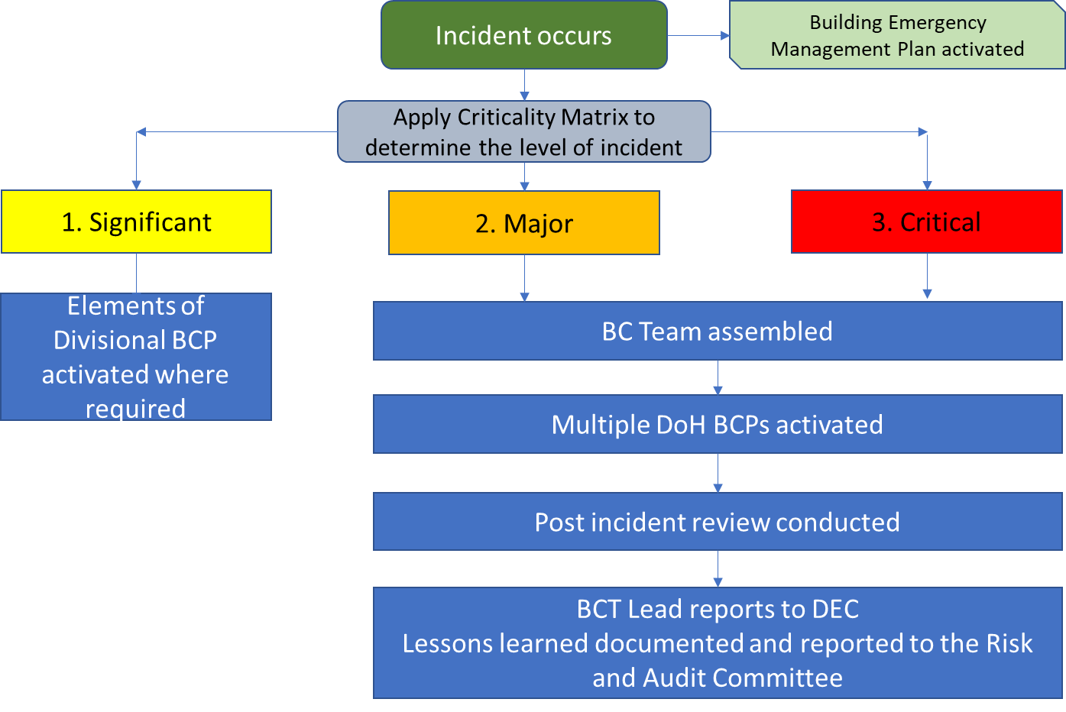

Communication
All communication or notifications to the department, its community, or media sources during a Major or Critical Incident will be coordinated through the BCT.
The Office of the DG (Communications team) will manage and maintain the communications strategy and tools used to engage with and inform the department’s community and stakeholders.

Roles and responsibilities
Roles and responsibilities for governance and oversight of BCM are defined in section 3.2 of the BCM Policy. The table below further details the roles and responsibilities for incident response and management, in the order of escalation.
Who | Responsibility
Chief Warden (Security Concierge) | - Activate the emergency response procedures as per the Emergency Management Plan.
Deputy Warden (Manager Business Services) | - Support implementation of the Emergency Management Plan.  - Facilitate relocation of critical functions to alternative locations where required.
Director, Corporate Services | - Provide appropriate resources (financial and people) to establish and manage an effective business continuity framework.  - Notify the BCT Lead of all incidents assessed as Level 2 Major or 3 Critical.  - Allocate appropriate resources to facilitate the resumption of critical business functions to support the BCT Lead within approved RTOs.
Business Continuity Team Lead (Deputy Director Genera) | - Activates the department-wide response and assembles the BCT.  - Direct the BCT members.  - Make critical decisions to support recovery efforts.  - Update the DG on a regular basis.
BCP Coordinator, Risk and Audit unit, Corporate Services | - Ensure that all relevant BCPs, BCT contacts and action cards are available should a BCP be activated.  - Assist the BCT Lead with assembling members of the BCT  - Provide support to the BCT Lead as required.  - Support identification of lessons learnt and reporting to DEC and RAC upon stand-down.
Divisional Representative | - Represent the division on the BCT  - Report to the ADG on BCT decisions and relevant impacts on the division.  - Provide leadership, guidance, and support to their division during a BCM event.
Business Continuity Team | - Manage and coordinate the department’s recovery efforts following a major or critical incident.
Assistant Directors General | - Activate divisional BCPs where relevant and oversee local level recovery efforts.
Department Executive Committee | - Provide leadership, guidance, and oversight to the department during a BCM event.  - Review post-incident reports following BCP activation and support ongoing improvements to the department’s BCM provisions.
Director General | - Receives regular updates from the BCT Lead.  - Holds ultimate accountability for the continuity of the department’s business operations.

Definitions
Term | Acronym | Description
Business Continuity Management | BCM | A management process that helps manage the risk to the smooth running of an organisation or delivery of a service, ensuring that it can operate to the extent required in the event of a disruption.
Business Continuity Plan | BCP | Documented procedures that guide the department to respond, recover, resume and restore to a predefined level of operation following a disruption.
Business Continuity Team | BCT | Designated individuals with responsibility for developing, execution, rehearsals, and the maintenance of the BCP.
Business Function | BF | A description of the work that is performed to accomplish a specific business requirement.
Business Impact Assessment | BIA | A method of assessing the impacts of an event that might result from an incident and the levels of resources and time required for recovery.
Critical Business Function | CBF | The critical operational and/or business support functions that cannot be interrupted or unavailable. At the department a CBF are those functions with a Maximum Tolerable Period of Disruption (MTPD) of 3 days or less as determined in the business impact analysis
Dependency |  | The reliance or interaction, directly or indirectly, of one activity, or process, or component thereof, upon another.
Disruption |  | An event that interrupts normal business, function, operations, or processes, whether anticipated or unanticipated.
Escalation |  | The process by which event-related information is communicated upwards through the department’s established levels of delegated authority.
Maximum Tolerable Period of Disruption | MTPD | MTPD refers to the time within which a business activity or service must be resumed following a disruption. It is measured from the time a disruption occurs to the time when the activity or service becomes operational again.
Recovery Time Objective | RTO | The period within which systems, applications, or functions must be recovered after an outage. RTO includes the time required for: assessment, execution, and verification

This document can be made available in alternative formats
on request for a person with a disability.
© Department of Health 2022

Copyright to this material is vested in the State of Western Australia unless otherwise indicated. Apart from any fair dealing for private study, research, criticism or review, as permitted under the provisions of the Copyright Act 1968, no part may be reproduced or re-used for any purposes whatsoever without written permission of the State of Western Australia.

