Statutory Review
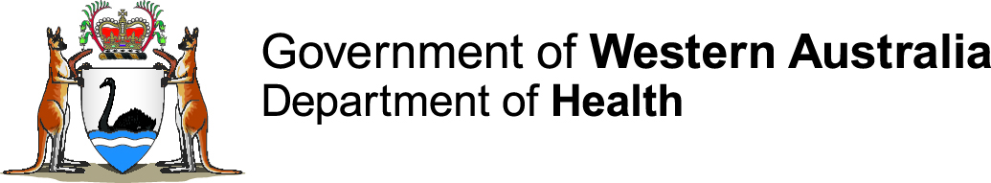
of the
Western Australian
Food Act 2008

Consultation Paper
2021

Contents
1.0 Introduction 4
1.1 Why are we conducting a review? 4
1.2 What will the statutory review cover? 4
1.3 The review process 4
1.4 Background to the Food Act 2008 4
2.0 How to make a submission 7
3.0 What happens next? 7

Introduction
The Food Act 2008 (the Act) provides for the safety and suitability of food for human consumption and related purposes. The Act is the key initiative in achieving national consistency in the regulation of food incorporating model provisions agreed to by the Commonwealth, States and Territories in the Food Regulation Agreement. The purpose of the Act is to improve the food regulatory system by providing for a risk-based approach to the management of the handling and sale of food for human consumption, together with robust enforcement tools to protect Western Australia’s food chain.

Why are we conducting a review?
The Minister is required to carry out a review of the operation and effectiveness of the Act and prepare a report for tabling in the Parliament. Interested persons are invited to make written submissions on the operation and effectiveness of the Act.

What will the statutory review cover?
The statutory review shall -
- Examine the operation and effectiveness of the Act in meeting its objects to:
- ensure food for sale is both safe and suitable for human consumption
- prevent misleading conduct in connection with the sale of food
- provide for the application in this State of the Food Standards Code.
- Identify, including through analysis of stakeholder submissions, any issues with the operation and effectiveness of the Act, including:
- interpretation | - taking and analysis of samples
- offences related to food | - auditing
- emergency powers | - registration of food businesses
- powers of entry | - administration
- inspection and seizure | - procedural and evidentiary provisions
- improvement notices and prohibition orders | - any other relevant matter.
- Make recommendations that will:
- strengthen and support the objects of the Act being met; and
- promote greater regulatory effectiveness.
The review will not capture documents outside of the Parts of the Act, including any external documents such as the Australian Standards, guidelines or policies.

The review process
The review commences on 1 December 2021. Interested persons and organisations are invited to provide their written submissions before the deadline of 14 March 2022.

Background to the Food Act 2008
In Australia, the three levels of government operate under a Joint Food System which incorporates elements of policy and food standards development, implementation and enforcement, and incident response to ensure food in Australia is safe to eat.
At the federal level, the Food Ministers from New Zealand and each Australian Minister for Commonwealth, State and Territory governments meet to develop food policy guidelines.
In 2000 the Food Regulation Agreement (FRA) became the basis of a national approach to food regulation and included Model Food Provisions Annex A and Annex B for State and Territory legislation. State and Territory governments, including Western Australia, committed to implement the cooperative national regulatory requirements and adopt the Model Food Provisions. In 2002 the FRA was amended to commit the Commonwealth, State and Territory Governments to national food regulation.
To implement the requirements of the FRA, the Food Bill 2005 (the Bill) was read into the Western Australian Parliament on 23 November 2005.
The Second Reading Speech and the Explanatory Memorandum here explains the intent of the Bill.
The Bill was referred to the Standing Committee on Uniform Legislation and Statutes Review. The report of the Standing Committee can be found here.
The Western Australian Food Act 2008 came into effect in 2009. During that time the provisions have been applied to all food businesses and specific primary production and processing activities. The administration and enforcement of the Act is carried out by the Department of Health and Local Government agencies.
The Food Act 2008 can be located here.

Food Act 2008
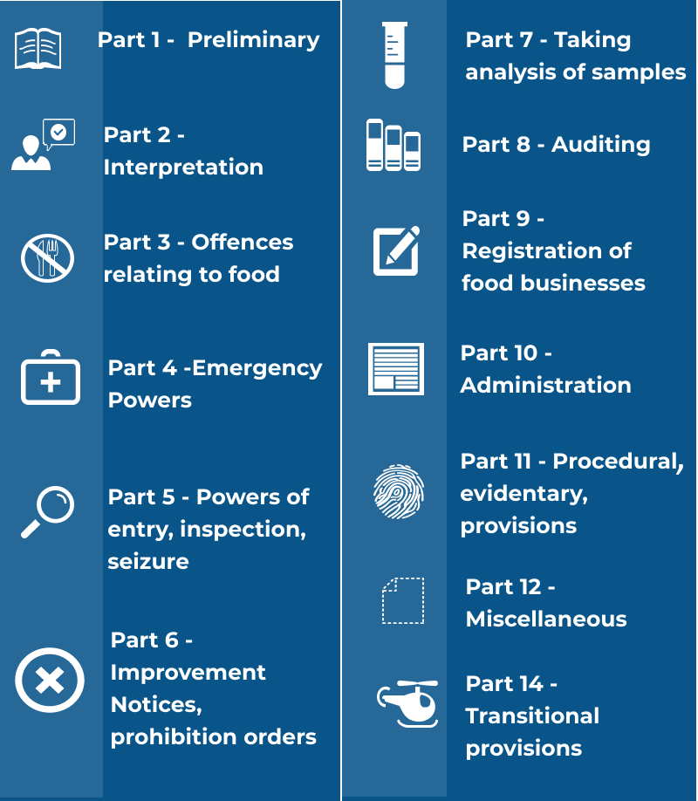

[Note that Part 13 was omitted under the Reprints Act 1984 section 7(4)(e).]

Questions
1. What is working well with the Act?
2. What, if any, changes should be made to the Act?
If you have suggested improvements please include any examples and studies that support your suggestions.

How to make a submission
Written submissions are invited from interested persons, organisations, and local government. For those working in local government, please ensure that your submission is Council endorsed. If you are responding on behalf of an organisation, please ensure the submission has your organisation’s endorsement and authorisation. Please allow time for the approval process of your organisation before the submission deadline.
Any relevant evidence-based research or studies that inform your submission are welcomed.
Written submissions can address any aspect of the Act and you are not required to comment on all parts of the Act.
Your submission will be part of a public consultation process and it may be quoted in the final report. Individuals or organisations who wish their comments to be treated confidentially should indicate this on their submission. Please note submissions may be subject to release under the Freedom of Information Act 1992.
Anonymous submissions will not be accepted. Submissions that address matters outside the scope of this Review will not be accepted.
Submissions can be made –
Online | Complete the Food Act Review comments section on the Consultation Hub
Email | Submit your written response and email to  reviewfoodact@health.wa.gov.au
Post | Post your submission to -  Review of the Food Act 2008  Environmental Health, Public and Aboriginal Health Division  Department of Health  PO Box 8172  Perth Business Centre WA 6849

What happens next?
At the close of the consultation period on 14 March 2022, submissions will be analysed, and a report prepared for the Minister.
The Minister will consider and table the report of the Review in the Parliament at a date to be set.
This document can be made available in alternative formats on request for a person with disability.

© Department of Health 2021
Copyright to this material is vested in the State of Western Australia unless otherwise indicated. Apart from any fair dealing for the purposes of private study, research, criticism or review, as permitted under the provisions of the Copyright Act 1968, no part may be reproduced or re-used for any purposes whatsoever without written permission of the State of Western Australia.

Food Regulation History, https://foodregulation.gov.au/internet/fr/publishing.nsf/Content/history-and-governance.
Ibid.

