DRAFT
WA Men’s Health and Wellbeing Policy
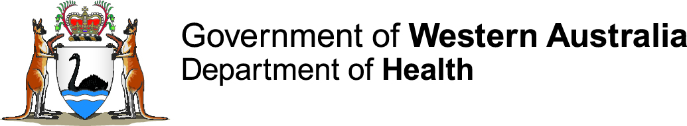
Consultation version

Produced by Health Networks © WA Department of Health 2018

Copyright to this material is vested in the State of Western Australia unless otherwise indicated. Apart from any fair dealing for the purposes of private study, research, criticism or review, as permitted under the provisions of the Copyright Act 1968, no part may be reproduced or re-used for any purposes whatsoever without written permission of the State of Western Australia.

Suggested citation

Western Australian Department of Health. draft WA Men’s Health and Wellbeing Policy. Perth: Health Networks, Western Australian Department of Health; 2018.

Important disclaimer

All information and content in this Material is provided in good faith by the Western Australian Department of Health, and is based on sources believed to be reliable and accurate at the time of development. The State of Western Australia, the Western Australian Department of Health and their respective officers, employees and agents, do not accept legal liability or responsibility for the Material, or any consequences arising from its use.

Contact information

For further information contact Health Networks, Western Australian Department of Health on (08) 9222 0200 or healthpolicy@health.wa.gov.au

Contents
Acknowledgements 3
Overview 4
Health disparities for men 6
Moving forward with the Policy 7
Guiding principles 7
Priority male populations 7
Policy components 9
Vision, purpose, goals and priorities 10
Areas for action 11
Using the Policy 19
Audience 19
Putting the Policy into practice 19
Monitoring the Policy 20
Glossary of terms 21
References 22
Appendices 24
Appendix 1: WA Men’s Health and Wellbeing Reference Group 24
Appendix 2: References for the Health Disparities for men infographic 25
Appendix 3: Related policies and frameworks 26
Appendix 4: Supporting documents – issues in depth 27

Acknowledgements
The draft Western Australian Men’s Health and Wellbeing Policy (the Policy) is the result of extensive consultation and considered commentary from a large number of organisations and individuals across the Western Australian health system and community. We would like to sincerely thank all those who contributed, especially the members of the Policy Reference Group (refer to Appendix 1), who provided content expertise and insight, community linkages, strategic guidance, and a commitment to optimise the health and wellbeing outcomes of men in WA.

Overview
Men are significant and positive contributors to life in WA through their diverse family, work and community roles.¹ They need to be empowered to continue this positive involvement, allow young men to reach their potential and to support all men to enjoy a long and high quality life.¹
However, men continue to face poorer outcomes than women on almost all measures of key health and wellbeing indicators.² They have lower life expectancy, and have higher levels of mortality from almost all non-gender specific causes of death including injury, cardiovascular disease, cancer, suicide, respiratory disease, and obesity.² In WA, males experience a greater total disease burden than females (age standardised rate = 208.0 males; 160.1 females).³ These health outcomes are primarily influenced by level of disadvantage; social and lifestyle factors such as smoking, excessive alcohol intake, and low fruit and vegetable intake; participation in high risk activities; tendency to use health and community services less and at a later stage when encountering a health or illness concern; and poorer social connections.² The Health disparities for men infographic on page 6 of this document clearly depicts the crisis of men’s health and wellbeing and the need for more action to be taken in WA to address and prioritise the issue.
From a psychosocial, economic and social point of view, improving men's health and wellbeing is better for men, their partners and families, the community and the economy.² Supporting the health and wellbeing of men needs to be recognised as a whole-of-community issue. This should include a focus on promoting and facilitating men's healthy living and strengthening health and community service delivery to men.²
Although the men’s health and wellbeing sector in WA lacks a clear definition and identity, there is an existing network of services that can be leveraged as the vehicle for improving men’s health and wellbeing outcomes.¹ All services must recognise and address the health and wellbeing needs of men and ensure they have a more strategic, coordinated and gendered approach.²
A timely response – WA Men’s Health and Wellbeing Policy
A policy approach that can engage and empower men and align the systems, services and communities that support them is urgently needed. The benefits of prioritising and addressing men’s health and wellbeing will be far reaching not just for men, but also their partners, families, the community and the economy. The development of the draft Western Australian Men’s Health and Wellbeing Policy (the Policy) is the first step towards recognising this important issue and calling people to action in WA. For the purpose of this Policy, the term ‘men’ refers to a male of any age, including boys.
The Policy was developed by the Health Networks Branch, WA Department of Health to demonstrate the WA health system’s commitment towards achieving the priority areas of the National Male Health Policy: Building on the strengths of Australian males.⁴
The purpose of this Policy is to provide direction to the WA health system and its partners to deliver strategies to improve the physical, mental, social and emotional wellbeing of men and boys living in WA.
The Policy recognises that the health and wellbeing of men is influenced by the complex and interwoven web of individual, interpersonal, organisational, social, environmental, political and economic factors know as social determinants of health.⁵ They encourage us to have a deeper understanding of health than a focus on biology, physiology and anatomy.

Figure 1. Social determinants of health⁶
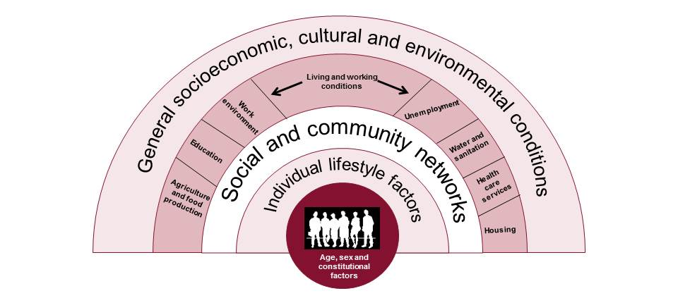
Acknowledging this reaffirms that men’s health and wellbeing is the joint responsibility of many agencies and departments beyond the WA health system and necessitates a collaborative approach to achieve common goals.
The Policy is structured to include three goals, followed by areas for action which provide direction on how to accomplish what is needed. The goals and areas for action were developed in consultation with a broad range of stakeholders, including men. This consultation was considered key in ensuring the purpose of the Policy accurately reflected the needs of men, and that the actions were tangible for those working with men and their communities throughout WA.
The goals are:
- Men are empowered to be proactive in managing their health and wellbeing
- Men have equitable access to services (including prevention and early intervention initiatives) that meet their needs
- Men’s health and wellbeing needs are monitored, evaluated and inform continual improvement of programs, services and initiatives.

Health disparities for men
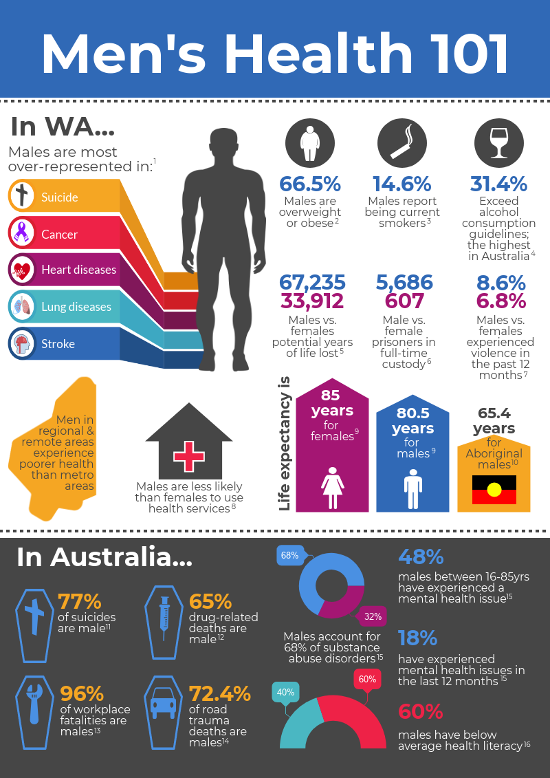
See Appendix 2 for references

Moving forward with the Policy

Guiding principles
The following guiding principles set the foundation for the intent of the Policy. They exist to ensure that men are supported and empowered to strive for and maintain good health.
People- and community-centred
Men are involved in all decisions regarding their health and wellbeing. Men are equal partners in planning, developing and monitoring health services that impact on men.
Health equity and access
Equitable access to health services optimises the health and wellbeing of all men.
Highest quality
Programs and services are evidenced-based or evidence-informed, and seek continuing improvement to achieve best-practice. Opportunities for innovation in program and service design are explored. Programs and services are co-designed, monitored and evaluated with engaged community members.
Holistic
Services recognise that the health and wellbeing of men can be improved by influencing the social determinants of health (see Figure 1).
Collaborative
Action to improve men’s health and wellbeing will be best achieved by the collective impact and shared commitment of multiple government and non-government organisations, communities and men.
Actions across the continuum
Services adopt a flexible, gendered approach to recognise and respond to the unique and diverse health and wellbeing needs of men (of all ages and at all stages of life) across the continuum, starting with a focus on prevention.

Priority male populations
Priority male populations is the term used within the Policy to highlight vulnerable men who may have complex needs and are at higher risk of:
- poor health and wellbeing outcomes
- barriers to access of health care
- health risk behaviours.
The priority male populations listed in the Policy reflect some of those groups who experience inequalities in health and wellbeing outcomes including contributing poor health determinants such as marginalisation, education, poverty and gender. The list is not exhaustive; populations may overlap and encompass varying characteristics and experiences. These priority male populations have been demonstrated to represent a higher risk of men’s health and wellbeing issues, particularly in relation to chronic conditions, and include:
- Aboriginal men
- Men with mental health issues
- Young men
- Men living in rural and remote areas
- Men in low socioeconomic circumstances
- Culturally and linguistically diverse (CaLD) men
- Older men.
In identifying these priority male populations, it is emphasised that the Policy also focusses on the majority of men, who are not in these categories, but have health and wellbeing issues that need to be addressed.

Policy components
The Policy outlines three goals, developed in consideration of the National Male Health Policy: Building on the strengths of Australian males⁴ with reference to the specific needs of men in WA.
Priority areas for action are identified under each of the goals for more detail and context.
The Policy also recognises the following domains as the levers for achieving the goals. For the purpose of this Policy, the Ottawa Charter for Health Promotion⁷ domains have been used in order to provide a proven approach that addresses the need for a holistic and collaborative approach to the many and complicated issues that affect men’s health and wellbeing. The five domains are:
- Build healthy public policy
Policy development at all levels seeks to promote health and wellbeing. It includes: legislation, fiscal measures, taxation, and organisational change. Health, income and social policies are used to foster equity and ensure safer and healthier goods and services, healthier public services, and cleaner more enjoyable environments. Policies need to identify obstacles to health and seek to remove them, making the healthier choice the easiest one.
- Create supportive environments
There is a link between people’s health and wellbeing and their environment. Work and leisure environments should promote health and wellbeing. Therefore health promotion should create safe working environments that are enjoyable, assess health impacts of developing infrastructure (buildings, energy etc), and protect natural and built environments.
- Strengthen community actions
Community action is strengthened through communities being involved in setting priorities, making decisions, planning strategies and implementing them to improve health outcomes. The process’ goal is to empower communities, which improves outcomes of health promotion.
- Develop personal skills
Requires the provision of information, education and life skill development. This increases options and control for individuals over their own health. It is essential to equip people for life-long learning and to develop skills for coping with ill health. This is done through school, home, and community settings.
- Reorient health services
The shift towards a system which promotes health, rather than curative services. The shift is to focus on the needs of the entire individual, not just their injury, illness or disease.
Specific areas for action are mapped under each of the domains and describe what is needed to be done. The areas for action focus on social determinants and an approach which capitalises on the strengths of men. It is recognised that there may be additional potential strategies to address men’s health and wellbeing. However the following goals, priority areas and actions focus on those that are deemed to have the greatest impact on the specific health needs of men in WA, based on feedback from local consultations and data.^{1-4, 8-22}

Vision, purpose, goals and priorities

Areas for action
Domain |  | Areas for action | Goal 1 | Goal 2 | Goal 3
A. Build healthy public policy | A1 | Promote the importance of addressing men’s health and wellbeing and recognise gender disparities among government agencies and service providers by:  - advocating for this Policy to be used as the foundation for development of policies impacting on men's health and wellbeing across government (e.g. prison health)  - ensuring any initiatives stemming from this Policy align with existing structures, strategies, plans and coordination mechanisms at both a state and national level to avoid duplication or siloed approaches e.g. Sustainable Health Review  - seeking acknowledgement of the need to contribute funding and resources towards men’s health and wellbeing in WA, especially where disparities exist. | X | X
 | A2 | Ensure policy planners involve men in design, development and evaluation of policy to ensure men's needs remain core to the policy process. | X | X | X
 | A3 | Create men’s health and wellbeing policies and policy implementation plans that:  - are flexible enough to adapt to emerging health and population trends  - consider the impact on men’s health and possible impacts on priority male populations in WA  - focus actions on trying to promote change to fundamental social determinants of health that are at the heart of problem  - prioritise service provision and funding towards priority male populations, where appropriate in WA . |  | X
 | A4 | Develop standards and frameworks for commissioning/procurement of men's health and wellbeing programs, services and campaigns that:  - foster empowerment and self-management  - are evidence-based or evidence-informed and evaluated, while allowing opportunity for innovation  - are holistic, culturally appropriate, and designed for men with men’s involvement at all levels and ages  - address common unhelpful stereotypes  - adopt strength-based approaches e.g. reinforcing the importance of men in the community and that taking care of personal health is a sign of strength and enables men to maintain their roles as wage earners, partners, carers, family members and friends. | X | X
 | A5 | Look for opportunities to integrate the WA Men's Health and Wellbeing Policy into local planning and environments in which men live and work and identify opportunities in local government for health and wellbeing plans. | X | X
 | A6 | Strengthen the evidence base that helps us to understand the way men think and respond to their health and wellbeing, and their barriers for accessing support or services. This can be achieved through:  - reviewing international research on barriers and enablers of men's uptake of health services over the generations  - promoting the need for better testing of education and treatment messages nuanced for men. |  | X
 | A7 | Give attention to research in men’s health especially in areas that:  - consider the interaction of the social determinants of health on sex, age and different population groups of males, including those from gay, bisexual and transgender groups and culturally diverse population groups  - focus on men living in rural or remote areas  - focus on Aboriginal men’s health in partnership arrangements with Aboriginal men  - identify strategies to build resilience in adolescents and adult men to enable them to deal effectively with adverse life events such as divorce and re-parenting.⁴ |  |  | X
 | A8 | Explore the potential for surveys such as the WA Health and Wellbeing Surveillance System Survey to establish baselines of health and wellbeing and use the data to re-shape health service delivery. |  | X | X
 | A9 | Build routine evaluation of health outcomes into health programs and services and ensure results are disseminated as widely as possible, including to men and in formats that are accessible and understandable to individuals, for example⁴:  - establish a framework and tools to measure the quality and performance of health promotion initiatives  - create a set of standard minimum demographic information to collect from participants in local programs (i.e. sex, age, geographic location, ethnicity and other variables that are relevant to measuring health outcomes for particular population groups of males) |  | X | X
B. Create supportive environments | B1 | Seek opportunities to bring together quality services and initiatives which recognise and cater to diversity, to be accessible by men and their families in their communities and work environments. For example:  - collaborate with key health organisations such as the Royal Australian College of General Practitioners (RACGP), beyondblue or Primary Health Networks to deliver evidence-based health checks, screening for stress and mental health issues and health promotion programs to employees.⁴ |  | X
 | B2 | Explore opportunities for the establishment of an online resource centre to be a central repository for resources, services and advice for the community on men's health and wellbeing. | X | X
 | B3 | Encourage service providers, workplace and community organisations to develop supportive spaces and culture for men to have discussion and seek support on health and wellbeing issues, e.g. relevant literature in waiting rooms, screen tools and literature or e-health kiosks | X | X
 | B4 | Develop strategies to connect men with local services that support their health and wellbeing. This would enable the linkage of men to quality evidence-based services via a number of mediums (online, telephone, social media and face–to-face) to enable accessibility.² | X | X
C. Strengthen community actions | C1 | Identify a credible peak body for men's health and wellbeing to coordinate, promote, support, and represent the needs and activity of health service providers within the WA health sector.² |  | X
 | C2 | Consider the development of a men’s health action group that brings together stakeholders from across community, government, non-government and industry sectors to:  - generate conversations and activities that keep men's health and wellbeing front of mind and advocate for support on action on areas of the WA Men's Health and Wellbeing Policy  - provide an opportunity for inter sectoral partnerships and collaboration for common projects and goals  - share new and existing data and research into men’s health and wellbeing  - share information on current initiatives in men’s health and wellbeing to avoid duplication and combine resources where appropriate  - promote and facilitate the implementation of the WA Men’s Health and Wellbeing Policy  - adopt a collaborative approach to seeking funding and investment opportunities for the development and delivery of new health and wellbeing-related research, initiatives and services. | X | X
 | C3 | Identify men’s health advocates within organisations and services that impact on men’s health and wellbeing. | X | X
 | C4 | Create a network of local champions / community advocates / ambassadors to promote key messages and address negative stereotypes (e.g. collaboration with local YouTube stars or online gaming community). | X
 | C5 | Acknowledge, respect and celebrate, at all levels of society, the positive roles of all men regarding cultural practices, obligations, parenting and spirituality, and interconnectedness between individuals, families and communities. | X
 | C6 | Acknowledge and celebrate at all levels of society the valuable roles men play in family and community life.⁴ This could be done through:  - all health practices providing family-friendly services that are openly inclusive of fathers  - childcare providers and family community services actively encouraging the involvement of fathers  - media promoting men as positive family members and routinely presenting images of males with children when reporting on families  - schools promoting positive roles of men begin to address gender stereotyping. | X
 | C7 | Recognise and foster the role of women in supporting their son, husband, father, brother to take early steps towards prevention of risky behaviours and accessing assistance for their health and wellbeing. | X
D. Develop personal skills | D1 | Provide comprehensive, evidence-based health promotion strategies, programs and interventions that target education, skill building, behaviour change and attitude change to empower and enable men as part of the community to take charge of their health and act to create positive and lasting change. | X
 | D2 | - Address attitudes and social stigmas by:  - acknowledging an individual's motivation to seek, and accept information or advice  - tapping into men’s self-reliance, independence and resilience to encourage them to be more active in seeking professional health advice  - making it socially acceptable to have regard for your health, and to get help or ask for help  - addressing the ‘she’ll be right’ attitude and associated stereotypical attitudes  - promoting that improving the health and wellbeing of men positively impacts the health and wellbeing of women, children, families, the economy, the workforce and the broader community¹  - talking about the positive sides of being a man, in the paradigm of masculinity, i.e. the man that takes everything in life as a challenge and meets life head-on; the man that is grounded in himself that has an understanding of his own social/spiritual wellbeing; the man that has qualities of good character.
 | D3 | - Support behaviour change (including increasing knowledge and skills of preventive and protective health behaviours) in the following ways:  - grow men's capacity for meaningful connection (first with other men, then with support services) and the understanding that they have both a 'right' and a 'responsibility' to engage, for their own benefit, and for their families and communities.  - school programs that encourage building of self-esteem, self-reliance, resilience and respect for self and others  - health programs for chronic disease prevention, mental health, drug and alcohol  - health education for men in workplaces, focusing on modifiable risk factors for preventative conditions  - health services, health professionals and support staff share information with men on obtaining a Medicare card, understanding bulk billing, accessing affordable health care, using private health insurance and the National Disability Insurance Scheme.  - engage men of all ages with innovative activities, education and strategies; for example community activities directed to the mix of talents and interests of young males, including sport, art, music, theatre, dance, volunteer and social groups.⁴
 | D4 | - Support skill development through:  - health literacy  - skills related to physical activity, nutrition, and mental and emotional wellbeing.
E. Reorient health services | E1 | Develop guidelines for male-friendly health services to engage men, their families and communities which recognise:  - that gender along with other social and cultural determinants impact upon the health and wellbeing of ’males’  - the importance of culture and connection to country, spirituality, family and community in order to provide accessible and culturally safe care for Aboriginal and Culturally and Linguistically Diverse men²³  - barriers men experience in accessing health services  - the aims and objectives of health service delivery for men  - priorities and key strategies to optimise men’s health and wellbeing  - the need for a focus on positive, relatable, accessible and non-judgemental care  - the importance of involving men and their communities in the co-design of the services  - how to measures the effectiveness and appropriateness of services to men using evaluation to inform service improvements. | X | X | X
 | E2 | Plan time and space in existing systems for focused services for men that create a ’one stop service’ in a variety of locations (rural, metropolitan and telehealth options). |  | X
 | E3 | Actively promote, using all means (multimedia and community voices), the delivery of male-friendly health services. |  | X
 | E4 | Upskill health professionals with current best practice methods and approaches to use every consultation as an opportunity to engage men in a conversation about their health and wellbeing. | X | X
 | E5 | Review current practices to look for opportunities to reinforce or promote engagement in preventative and protective health activities such as: invitation to health checks, recall for health screenings, risk screenings in waiting areas. | X | X
 | E6 | Promote opportunistic screening or referral to appropriate services when men access services related to major life events such as:  - leaving school and early adulthood  - fatherhood – motivating factor for better self-care  - relationship failure (including divorce and limited or no contact with children following separation)  - loss of job/ unemployment  - transition out of Defence and other uniformed services  - traumatic life events  - personal injury or disease, e.g. diagnosis of chronic illness  - grief due to death or suicide  - commencing work  - becoming a carer  - LGBTI-related transitions ie. coming out. | X | X
 | E7 | Support capacity building in general practices to fully access Government incentives, including Medicare rebates for longer appointments to engage men in evidence-based chronic disease prevention (e.g. using the RACGP’s Red Book Guidelines for Preventative Practice in General Practice).⁴ |  | X
 | E8 | Increase the flexibility and options for accessing men’s health and wellbeing services; for example:  - co-location with other allied services  - outside of hours, face-to-face support (i.e. general practices taking up government incentives to extend opening hours)  - online booking options  - walk-in services or self/family referral  - mobile health services, particularly in rural areas²¹  - services in non-typical environments i.e. mobile health programs such as Pit Stop at agricultural shows  - outreach services for priority male populations, i.e. men who are homeless  - telehealth (virtual) clinics. |  | X
 | E9 | Improve the continuity of care through clear referral pathways between primary, secondary and tertiary health services, e.g. creating a men’s health and wellbeing HealthPathway. This includes linking men with appropriate community organisations for ongoing social support (i.e. Men’s Sheds, clubs and organisations).² |  | X
 | E10 | Focus on implementation and support of existing comprehensive health promotion and preventive health initiatives, programs and services in the community, and ensure community engagement events are supported by environmental and policy initiatives. | X | X
 | E11 | Implement sustainable systems for the education, training, mentoring and supervision of all health professionals and support staff working with men are implemented to achieve an understanding of effectively engaging and supporting men with their health and wellbeing. This includes undergraduate education and ongoing professional development and education in the workplace. Key messages include:  - gendered health behaviours of men⁴  - specific areas of health risk and chronic disease prevention relevant to men⁴  - occupational health and safety risks associated with traditional male employment, such as transport, construction and farming⁴  - awareness of health professionals and support staff to encourage men that come into their care to have ‘healthier male thinking’ about their own health and wellbeing  - remove stereotypes and stigmas that provide barriers to health care for men  - recognition that some groups of males can be discriminated against or feel marginalised for various reasons, including ethnicity, sexual orientation, homelessness or mental health issues, and that these can affect access to health care and uptake of health messages⁴  - the latest research and trends in men’s health and wellbeing needs  - how to provide practical and realistic strategies and interventions  - the skills needed to engage effectively with men, including cultural sensitivity and cultural awareness training.² | X | X
 | E12 | Promote relevant existing training tools and increase interactive learning opportunities for those providing services to men, i.e. online training packages, webinars. |  | X
 | E13 | Employ more male health staff, including those from Aboriginal and diverse backgrounds, particularly in mental health sector and social services. | X | X
 | E14 | Men are meaningfully involved in co-planning, design and evaluation of men’s health services, programs and facilities and their needs are recognised by health service planners.²⁴ | X | X | X

Using the Policy

Audience
The Policy recognises the interdependencies that exist between primary, secondary and tertiary health care, and their connection to social care.
The primary audience of the Policy is the WA health system, which includes:
- the Director General and the WA Department of Health, as System Manager for the WA health system
- Health Service Providers – North Metropolitan Health Service (NMHS), South Metropolitan Health Service (SMHS), WA Country Health Service (WACHS), Child and Adolescent Health Service (CAHS), East Metropolitan Health Service (EMHS), the Quadriplegic Centre and Health Support Services (HSS)
- contracted health entities.
Improvements in men’s health and wellbeing are the joint responsibility of a range of agencies beyond the WA health system that need to work collaboratively to achieve common goals. The Policy provides useful guidance on how all men, their families and carers, community and advocacy groups, health professionals and those who provide services for men can work collectively towards improving men’s health and wellbeing. It is recommended the approaches outlined within the Policy are adopted by multiple agencies, including, but not limited to:
- other Western Australian government agencies including the Department of Communities; Department of Education; Department of Justice; Department of Planning, Lands and Heritage; Department of Local Government, Sport and Cultural Industries; Department of Fire and Emergency Services; Public Transport Authority; and WA Police
- commissioning bodies including the Mental Health Commission and the WA Primary Health Alliance
- Commonwealth government agencies, including the Department of Health
- charitable organisations
- educational bodies
- non-government organisations.

Putting the Policy into practice
The Policy outlines the key elements to improve the health and wellbeing of men, including:
- attitudes (e.g. cultural factors, stigma, masculinity, perceptions regarding health)
- education/awareness (of conditions, risks, treatment, health impact and services)
- access to services (e.g. location, cost, availability of health services)
- community support and intervention (e.g. carers, family, friends, colleagues).
It is the intent of the Policy to inform local planning, delivery and evaluation strategies for health services and programs.
To achieve the greatest effect, it is recommended that:
- the Department of Health, Health Service Providers and health services develop implementation plans to deliver the recommended actions and achieve the three goals of the Policy
- men are meaningfully involved in the development of the implementation plans and the subsequent measurement of their impact
- the Policy is adopted as a multi-agency approach.

Monitoring the Policy
The Department of Health will support the implementation of the Policy by communicating it broadly across the WA health system and to all relevant external stakeholders. It will be available via the Health Networks website.
The Department of Health will measure the reach and level of awareness of the Policy as a form of evaluation. Potential uses for the Policy include:
- advocacy at an individual and organisational level to promote a shared understanding of the importance of addressing men’s health and wellbeing
- promotion of key messages and use as an aspirational document
- to inform education and training for consumers and professionals
- to support policy, legislation and program and service design and provision
- to direct, prioritise and drive relevant research
- as a networking tool to assist services to work collaboratively by sharing knowledge and resources and building systemic relationships.
Users of the Policy can build in measures of success into their individual implementation plans to review their activity and progress under the three goals.

Glossary of terms
Access | Access is viewed as the opportunity to identify healthcare needs, to seek healthcare services, to reach, obtain or use healthcare services, and to actually have a need for services fulfilled. There are five dimensions of accessibility:  1) approachability  2) acceptability  3) availability and accommodation  4) affordability  5) appropriateness.  Five corresponding abilities of populations interact with the dimensions of accessibility to generate access:  1) ability to perceive  2) ability to seek  3) ability to reach  4) ability to pay  5) ability to engage.²⁵
Department of Health as System Manager | The Health Services Act 2016 establishes the Department of Health, led by the Director General, as the System Manager responsible for the overall management and strategic direction of the WA health system, ensuring the delivery of high quality, safe and timely health services.²⁶
Health and wellbeing | The Policy adopts the holistic World Health Organization (WHO) definition of health: ‘complete physical, mental and social wellbeing and not merely the absence of disease and infirmity’.²⁷ It also recognises the spiritual dimensions of health and wellbeing.
Health literacy | How people understand information about health and health care, and how they apply that information to their lives, use it to make decisions and act on it.²⁸
Men | .
Mental health | ‘A state of well-being in which the individual realises his or her own abilities, can cope with the normal stresses of life, can work productively and fruitfully, and is able to make a contribution to his or her community’.²⁹

References
1. Men's Health & Wellbeing Western Australia. Western Australian Male Health and Wellbeing Policy Information Paper. Perth: Men's Health & Wellbeing Western Australia.
2. Men's Health & Wellbeing Western Australia. The health and wellbeing status of Western Australian Males 2016. Perth: Men's Health & Wellbeing Western Australia; 2017.
3. Epidemiology Branch, Public Health Division, Department of Health Western Australia. Overview of the burden of disease in Western Australia, 2011. Perth: Department of Health Western Australia; 2016.
4. Department of Health and Ageing. National Male Health Policy: Building on the Strength of Australian Males. Canberra: Department of Health and Ageing; 2010.
5. World Health Organization. About social determinants of health (online); 2018 (updated 2018; cited 8 May). Available from: http://www.who.int/social_determinants/sdh_definition/en/.
6. Dahlgern G, Whitehead M. Tackling inequalities in health: what can we learn from what has been tried? (online); 1993 (updated 2018; cited 1 May). Available from: https://www.kingsfund.org.uk/projects/time-think-differently/trends-broader-determinants-health.
7. World Health Organization. The Ottawa Charter for Health Promotion (online). Geneva, Switzerland: WHO; 1986 (updated 2018; cited 1 May). Available from: http://www.who.int/healthpromotion/conferences/previous/ottawa/en/index.html.
8. Australian Institute of Health and Welfare. The Health of Australia's Males. Canberra: Australian Institute of Health and Welfare; 2011.
9. Australian Institute of Health and Welfare. The health of Australia’s males: a focus on five population groups. Canberra: Australian Institute of Health and Welfare; 2012.
10. Australian Institute of Health and Welfare. The Health of Australia's Males: From birth to young adulthood (0-24 years). Canberra: Australian Institute of Health and Welfare; 2013.
11. Australian Institute of Health and Welfare. The Health of Australia's Males: 25 years and over. Canberra: Australian Institute of Health and Welfare; 2013.
12. Australian Institute of Health and Welfare. Mortality and life expectancy of Indigenous Australians 2008 to 2012. Canberra: Australian Institute of Health and Welfare; 2014.
13. Australian Institute of Health and Welfare. The health and welfare of Australia's Aboriginal and Torres Strait Islander peoples. Canberra: Australian Institute of Health and Welfare; 2015.
14. Department of Health and Ageing. National Male Health Policy Supporting Document: Access to Health Services. Canberra: Department of Health and Ageing; 2010.
15. Department of Health and Ageing. National Male Health Policy Supporting Document: Healthy Limits. Canberra: Department of Health and Ageing; 2010.
16. Department of Health and Ageing. National Male Health Policy Supporting Document: Healthy Routines. Canberra: Department of Health and Ageing; 2010.
17. Department of Health and Ageing. National Male Health Policy Supporting Document: Action Males Can Take Now. Canberra: Department of Health and Ageing; 2010.
18. Department of Health and Ageing. National Male Health Policy Supporting Document: Healthy Minds. Canberra: Department of Health and Ageing; 2010.
19. Department of Health and Ageing. National Male Health Policy Supporting Document: Social Determinants and Key Actions Supporting Male Health. Canberra: Department of Health and Ageing; 2010.
20. Epidemiology Branch. Specific disease burden in Western Australia, 2011. Perth: Department of Health WA; 2017.
21. Men's Health & Wellbeing Western Australia. A Quiet Crisis: Male Health in Rural, Remote and Regional Western Australia. Perth, Western Australia: Men's Health & Wellbeing Western Australia; 2016.
22. Tomlin S, Joyce S, Radomiljac A. Health and Wellbeing of Adults in Western Australia 2015, Overview and Trends. Perth: Department of Health Western Australia; 2016.
23. Department of Health Western Australia. WA Aboriginal Health and Wellbeing Framework 2015-2030. Perth: Department of Health Western Australia; 2015.
24. Quality Improvement and Change Management Unit. You Matter: A Guideline to support engagement with consumers, carers, communities and clinicians in health. Perth: Western Australian Department of Health; 2017.
25. Levesque JF HM, Russell G,. Patient-centred access to health care: conceptualising access at the interface of health systems and populations. International Journal for Equity in Health 2013;12(18).
26. Department of Health WA. Health Reform (online); 2018 (cited 23 February 2018). Available from: http://ww2.health.wa.gov.au/Improving-WA-Health/Health-reform
27. World Health Organization. Definition of Health – Preamble to the Constitution of the World Health Organization. International Health Conference; New York. Official Records of the World Health Organization, no. 2, p. 100 and entered into force on 7 April 1948; 19-22 June, 1946; signed on 22 July 1946.
28. Australian Commission on Safety and Quality in Health Care. Health Literacy (online); 2018 (updated 2018; cited 8 May). Available from: https://www.safetyandquality.gov.au/our-work/patient-and-consumer-centred-care/health-literacy/.
29. World Health Organization. Mental health: a state of well-being (online); 2014 (updated 2018; cited 8 May). Available from: http://www.who.int/features/factfiles/mental_health/en/.

Appendices

Appendix 1: WA Men’s Health and Wellbeing Reference Group
Name |  | Position and organisation
Aesen | Thambiran | Director, NMHS Humanitarian Entrant Health Service
Andrew | Robertson | Deputy Chief Health Officer
Craig | McAllister | Senior Policy Advisor, WA Primary Health Alliance
Dean | Dyer | Men’s Health and Wellbeing WA
Gary | Bryant | Executive Officer, Men’s Sheds of WA
Helen | Mitchell | Senior Development Officer, Health Networks
Joanna | Fagan | Director, Public Health and Ambulatory Care NMHS
Karen | Street | Director, Population Health (Geraldton) WACHS
Mark | Pestell | Area Manager, Mental Health SMHS
Matt | Tilley | Lecturer, Faculty of Health Sciences, School of Public Health Curtin University
Megan | Burley | A/Director, Health Networks
Nicole | Deprazer | Senior Development Officer, Health Networks
Owen | Catto | Senior Community Educator/Executive Officer, Regional Men’s Health Initiative (Royalties for Regions)
Paul | Coates | Chief Executive Officer, Carers WA
Rachel | O'Connell | Senior Policy Advisor, WA Primary Health Alliance
Richard | Crane | A/Manager of Health Promotion, SMHS
Rob | McPhee | Deputy CEO, Kimberley Aboriginal Medical Service Aboriginal Health Council for WA (AHCWA)
Tim | O'Brien | Director Community and Population Health Services, EMHS
Tim | Williams | Consumer and Community Engagement Coordinator, Health Consumers’ Council WA

Appendix 2: References for the Health Disparities for men infographic

- Australian Bureau of Statistics. Causes of Death, Australia. 2015. cat. no. 3303.0. ABS
- ABS. (2015). National Health Survey. (No. 4364.0). Canberra: ABS.
- HealthTracks. Summary of population characteristics and the health and wellbeing of residents of the Western Australia State. Epidemiology Branch, Department of Health WA in collaboration with the Cooperative Research Centre for Spatial Information (CRC-SI). Accessed 14 August 2017.
- ABS. National Health Survey: First Results, 2014-2015, cat. no. 4364.055.001. ABS. Accessed on 14 August 2017.
- MAN. The health and wellbeing status of Western Australian males and the MAN Forum Report. East Perth: MAN, 2014.
- ABS. (2016). Corrective Services, Australia, September quarter 2016. (No. 4512.0).
- ABS. (2013). Personal Safety Australia, 2012. (No. 4906.0).
- Tomlin, S., Joyce, S., & Radomijac, A. (2016). Health and Wellbeing of Adults in Western Australia 2015, Overview and Trends. Department of Health, Western Australia.
- ABS. Life tables, States, Territories and Australia, 2013-2015, cat. no. 3302.0.55.001. Canberra: ABS.
- AIHW. (2014). Mortality and life expectancy of Indigenous Australians, 2008 to 2012. (Cat. no. IHW 140).
- ABS. (2016). Leading causes of death and Years of Potential Life Lost, 2015 (a)(b)(c)(d)-Leading causes YPLLs for top 20. ABS.
- ABS. (2013). Gender Indicators, Australia, Jan 2013. (No. 4125.0).
- Safe Work Australia. (2016). Work-related traumatic injury fatalities, Australia. Retrieved from www.safeworkaustralia.gov.au/sites/SWA/about/Publications/Documents/979/work-related-traumatic-injury-fatalities.pdf
- ABS. (2014). Australian Social Trends, July 2013. (No. 4102.0)
- Extracted from HealthTracks Leading Health Conditions, Total potentially preventable hospitalisations and rates for Western Australian residents by chronic condition, 2011-2015
- ABS. (2008). Adult Literacy and Life Skills Survey, Summary Results, Australia, 2006. (No. 4228.0).

Appendix 3: Related policies and frameworks
The following policies and frameworks have been used to inform the development of the Policy.
- National Male Health Policy: Building on the strengths of Australian males
- WA Health Strategic Intent 2015–2020
- WA Aboriginal Health and Wellbeing Framework 2015–2030
- WA Health Promotion Strategic Framework 2017–2021
- WA Women’s Health Strategy 2013–2017
- WA Disability Health Framework 2015–2025
- WA Youth Health Policy 2018–2023: Strong body, strong minds - stronger youth
- Victoria’s Improving Men’s Health and Wellbeing: Strategic Directions
- New South Wales Department of Health’s Men’s Health Plan 2009–2012
- National Men’s Health Action Plan: Healthy Ireland Men 2017–2021

Appendix 4: Supporting documents – issues in depth
Statistics
The development of the Policy was informed by evidence in a range of international, national and WA sources in the area of men’s health and wellbeing. This included a targeted online survey conducted in late 2017 by Health Networks to capture views from the men’s health and wellbeing sector on important considerations for the WA health system including priority populations and risk factors, strengths and weaknesses of current strategies, and opportunities for future efforts to promote health services to WA men. Other sources include reports by the Australian Institute of Health and Welfare, Men’s Health and Wellbeing WA, the Commonwealth Department of Health and the WA Department of Health:
- A Quiet Crisis: Male Health in Rural, Remote and Regional Western Australia Report (Men’s Health & Wellbeing WA)
- Caring in Focus – Male Carers (Carers WA)
- Health and Wellbeing of Adults in Western Australia 2015 – Overview and Trends (Department of Health WA)
- Incidence and costs of injury in Western Australia 2012 (WA Department of Health)
- Male Health and Wellbeing WA Sector Needs Analysis Report 2016 (Men’s Health & Wellbeing WA)
- Mortality and Life Expectancy of Indigenous Australians 2008 to 2012 (Australian Institute of Health and Welfare [AIHW])
- National Male Health Policy Supporting Documents (Australian Government Department of Health)
  - Access to Health Services
  - Healthy Limits
  - Healthy Minds
  - Healthy Routines
  - Social Determinants and Key Actions Supporting Male Health
- Overview of Burden of Disease in Western Australia 2011 (October 2016 – Department of Health WA)
- Specific Disease Burden in Western Australia 2011 (April 2017 – Department of Health WA)
- The Health and Welfare of Australia’s Aboriginal and Torres Strait Islander Peoples Report 2015 (AIHW)
- The Health and Wellbeing Status of Western Australian Males 2016 (Men's Health & Wellbeing WA)
- The health of Australia’s males (AIHW)
- The health of Australian males: a focus on five population groups (AIHW)
- Western Australian Chief Health Officer’s Report 2010 (Department of Health WA)
- Western Australian Male Health and Wellbeing Policy Information Paper (Men's Health and Wellbeing WA)

Consumer resources
- Effectively Engaging with Men resource (ConnectGroups)
- Blokes Book and Pocket Directory (Men’s Health and Wellbeing WA)

This document can be made available in alternative formats
on request for a person with a disability.
© Department of Health 2018
Copyright to this material is vested in the State of Western Australia unless otherwise indicated. Apart from any fair dealing for the purposes of private study, research, criticism or review, as permitted under the provisions of the Copyright Act 1968, no part may be reproduced or re-used for any purposes whatsoever without written permission of the State of Western Australia.

culture refers to values, traditions, beliefs, interactions, behaviours and attitudes.

